**Liquid Fuel Production from Biomass Tar by Hydrogenation**

***Dr. Moe Thanda Kyi *1), Dr. Reiji Noda 2)***

1. *Professor and Head, Fuel and Propellant Engineering Department,*

*Myanmar Aerospace Engineering University, Myanmar*

[moethandakyi@gmail.com](mailto:moethandakyi@gmail.com)

1. *Associate Professor, Graduate School of Science and Technology*

*Division of Environmental Engineering Science, Gunma University, Japan*

**Abstract**

We observed that bio - oils production from heavy tar which is organic phase of pyrolysis oil using CoMo/Al2O3 catalyst in the bench scale hydrogenation process. This experiments were carried out at varying temperatures 300,400 and 500°C in hydrogenation reactor. The effect of reaction temperature, retention time, feed rate, space velocity (SV), hydrogen concentration, and catalyst loading factor on bio-oil yield, carbon content, and carbon recovery of heavy tar by catalytic conversion was investigated. The six variables ranged from 300 to 500 °C for temperature,0-140 min for retention time, 1,2, and 3.3 g-tar/min for feed rate,0.1,0.2,and 0.4 s-1 for SV, 25,50, and 75 v% for hydrogen concentration, and 1.3,2.7 and 4.4 mg-tar /min/g-cat for catalyst loading factor. The product oils analyzed using Karl Fischer moisture titrating analyzer, Total organic carbon (TOC) analyzer, GC – 14A gas chromatography, Agilent 3000 micro gas chromatography and elemental analysis. It was found that maximum bio-oil yield of 29wt% was obtained at 400°C,60-140 min,2 g-tar/min feed rate,0.2 s-1 SV,50 v% hydrogen concentration and 2.7 mg-tar /min/g-cat catalyst loading. In this study, it was able to produce a high quality liquid fuel with minimum water content 0.3wt% in oil phase and maximum level of HHV (39.8MJ/kg). The oil was also observed to have an abundant amount of aromatic compounds. It was possible to produce multi-component fuels through the hydrogenation of bio-oils from heavy tar.

**Keywords:** Bio-oil; Bio-oil yield; Catalytic conversion; CoMo/Al2O3 catalyst; Heavy tar

**Introduction**

The Government of Myanmar is undertaking measures to increase private sector participation by attracting foreign direct investment for accelerating the growth of development of the renewable energy sector. Formulate projects that support research and development on variety improvement of bio fuel technology and bio fuel processing contain human resource development, upgrading laboratory facilities, standardization of quality and control, and production and distribution of bio fuels.One of the challenges of this process is, thus, the control over the extent of hydrogenation. This paper aims to give methods of hydrogenation liquefaction and liquid fuel production from heavy tar and their potential of development. The main objectives of this research are; a. To understand biomass hydrogenation liquefaction process, b. To know presulfurization condition for hydrogenation catalyst, c. To determine the yield of liquid fuel in various reaction conditions.

**Material and Methods**

The experiments were conducted using a fixed – bed reactor in a batch process at atmospheric pressure. The height and inside diameter of the reactor were 558 and 152 mm respectively. Two fluids nozzle was used in the evaporator. CoMo/Al2O3 catalyst was used in this study. Figure 1.1 showed the schematic diagram of experimental apparatus. This unit consists of burner, fixed – bed reactor, thermocouple to control the top and bottom temperature, feeder machine to supply the specified amount of feedstock into the reactor, gas flow meters to supply gases such as hydrogen, nitrogen and hydrogen sulfide, liquid collector to trap total liquid products, dry test gas meter and gas collection bag.

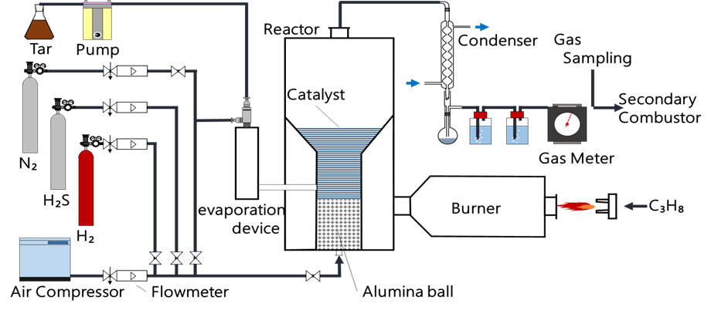

**Figure 1.1, Schematic diagram of experimental apparatus**

**Results and Conclusions**

Table 1.1 showed liquid production experiments under an appropriate operation results.

**Table.1.1, Liquid production experiments under an appropriate operation results**

|  |  |  |  |  |  |  |  |
| --- | --- | --- | --- | --- | --- | --- | --- |
| **Exp: No.** | **Oil yield, wt%** | **Water content in oil phase, wt%** | **HHV, MJ/kg** | **Oxygen content, wt%** | **Carbon content, wt%** | **H/C, mol/mol** | **O/C, mol/mol** |
| 1 | 4 | 1.6 | 36.7 | 9.66 | 83.06 | 1.0 | 0.1 |
| 2 | 13 | 1.5 | 39.8 | 4.48 | 88.02 | 1.0 | 0.0 |
| 3 | 29 | 0.3 | 39.3 | 5.75 | 86.66 | 1.0 | 0.0 |

This research showed that the recovery of liquid fuel from heavy tar, which is organic phase of pyrolysis oil was successfully performed using a catalytic conversion. This experiment also confirmed that the temperature and reaction time have a significant effect on the distribution of product yields obtained from the catalytic conversion. A temperature of around 400 °C and longer time were found to be most suitable for catalysts to perform the de-oxygenation activity, which caused an increase in the production of water and gas. In this study, it was able to produce a high quality liquid fuel with minimum water content 0.3wt% in oil phase and maximum level of HHV (39.8MJ/kg). The oil was also observed to have an abundant amount of aromatic compounds. Finally, we concluded that the characteristics of product oil were very close to those of gasoline and that the product oil has the potential to be used as a transportation fuel.

**References**

Adjaye, J. D.; Bakhshi, N. N. (1995), Biomass Bio energy. 8, 131−149.

Cortright RD, Davda RR, Dumesic JA (2002), Hydrogen from catalytic reforming of biomass derived hydrocarbons in liquid water. Nature. 418:964–967.

Czernik S, French R, Feik C, Chornet E (2002), Hydrogen by catalytic steam reforming of liquid byproducts from biomass thermo conversion processes. Ind Eng Chem Res 41:4209–4215.

French, R.; Czernik, S. (2010), Fuel Process.Technol. 91, 25−32.

Lim, X.Y. Andre sen, J.M. (2011), Fuel Process. Technol. 92, 1796-1804.

Sharma, R. K.; Bakhshi, N. N. (1993), Energy Fuels. 7, 306−314.